PATHSHALA NEPAL FOUNDATION

PRE-UNI PROGRAM

Baneshwor, Kathmandu



Lab Assessment Report on

Use of Pointer

**Submitted By:** **Submitted To**

Name: Raunak Raj Adhikari Department of Computer Science

Class: 12 PATHSHALA NEPAL FOUNDATION

Group: 2

Date: 2023-09-23

**ANSWER THE FOLLOWING:**

1. Define pointer. How is pointer declare and used in a C program? Explain with an example.
2. Highlight the advantages of use of pointer.
3. Show the differences between parameter passing by reference and by value with a suitable example.
4. Explain briefly about different storage classes used in C with example of each.

**Write a C Program:**

1. To illustrate the use of pointer.

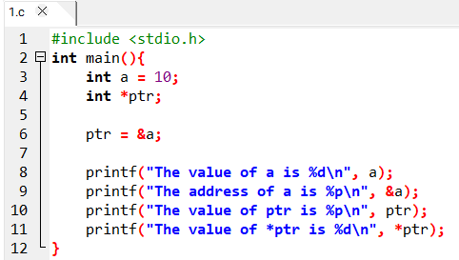

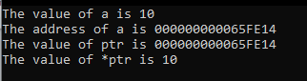

1. To exchange the values of two variables using pointers.

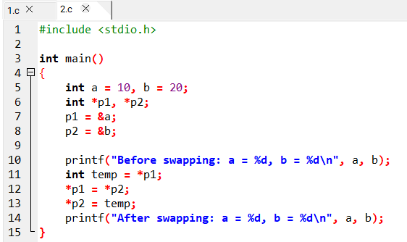



1. To illustrate the use of pointer of pointer.

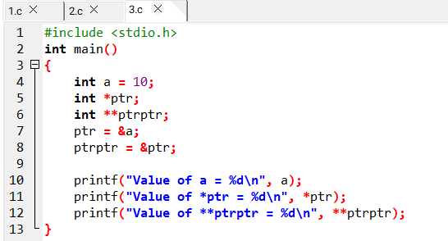

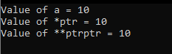

1. To ask a user for supplying principle time rate of interest and time period in year and calculate simple interest and amount using pointers.

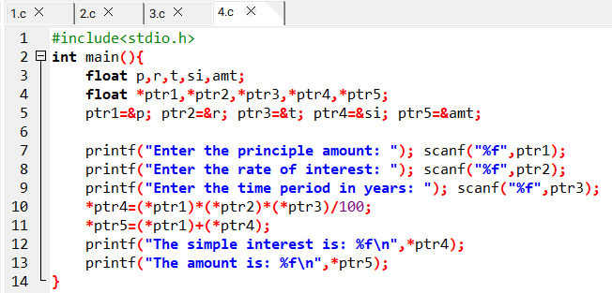

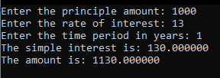

1. To find the average of any two integers input by a user by using pointers.

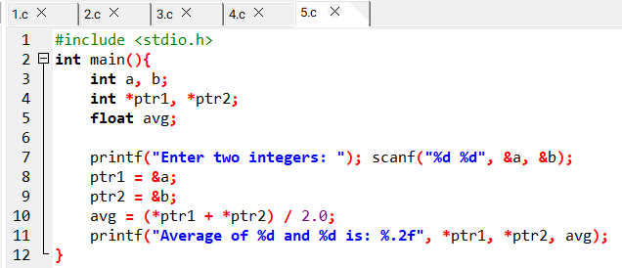



1. To find out the greater value between any two integers input by a user by using pointers.

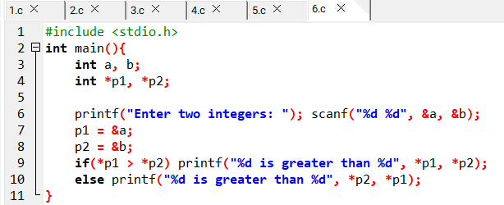



1. To ask a user for supplying any ten integer values and calculate sum and average using pointer.

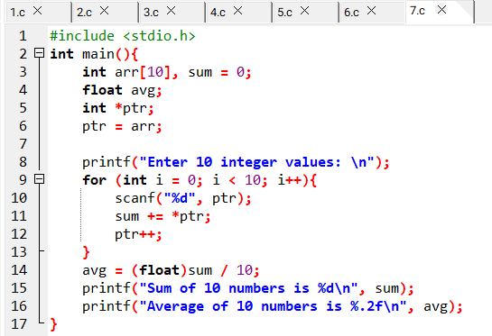

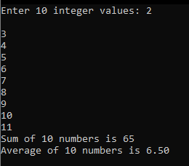

1. To illustrate with example to show the difference between parameter passing by reference and by value.

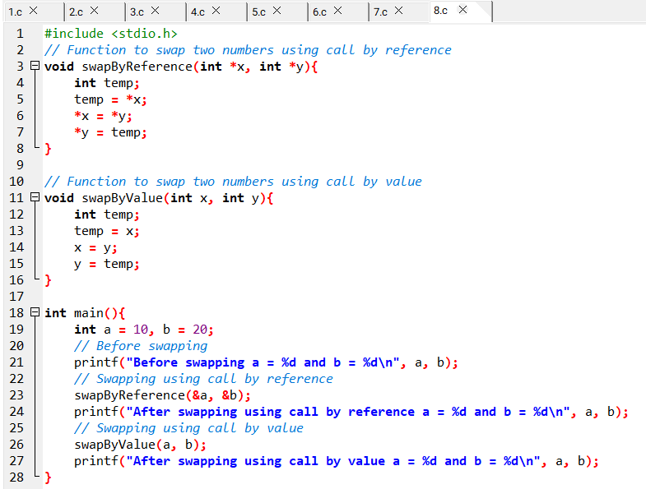

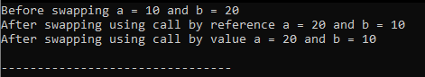

1. To find out the sum average maximum and minimum among n different values input by a user by using pointer.

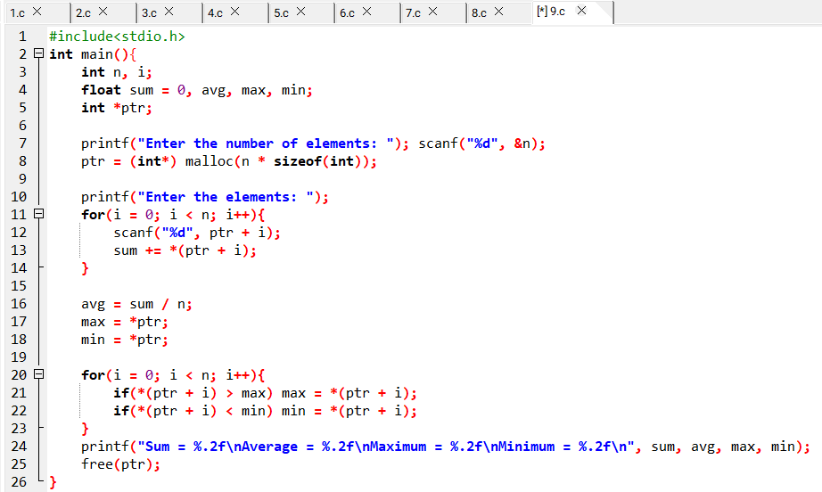

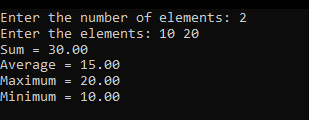

1. To find out the sum average maximum and minimum among n different values input by a user by using pointer. 